Exercise 1
Set up a new API using AWS API Gateway. Create a resource and method (GET) that returns a simple static message (e.g., "Hello, World!") in response to an HTTP request. Deploy the API to a new stage (e.g., "dev"). Test the API using Postman/Insomnia or a browser.



REST API:
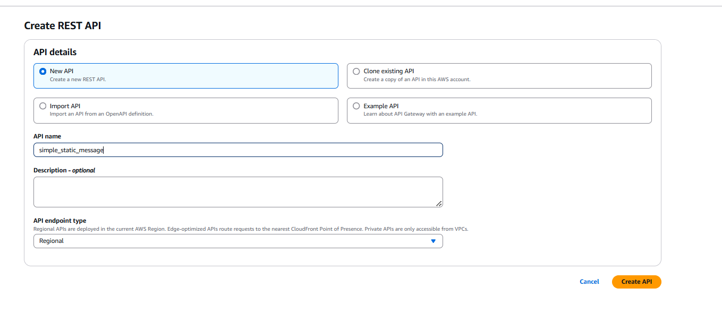
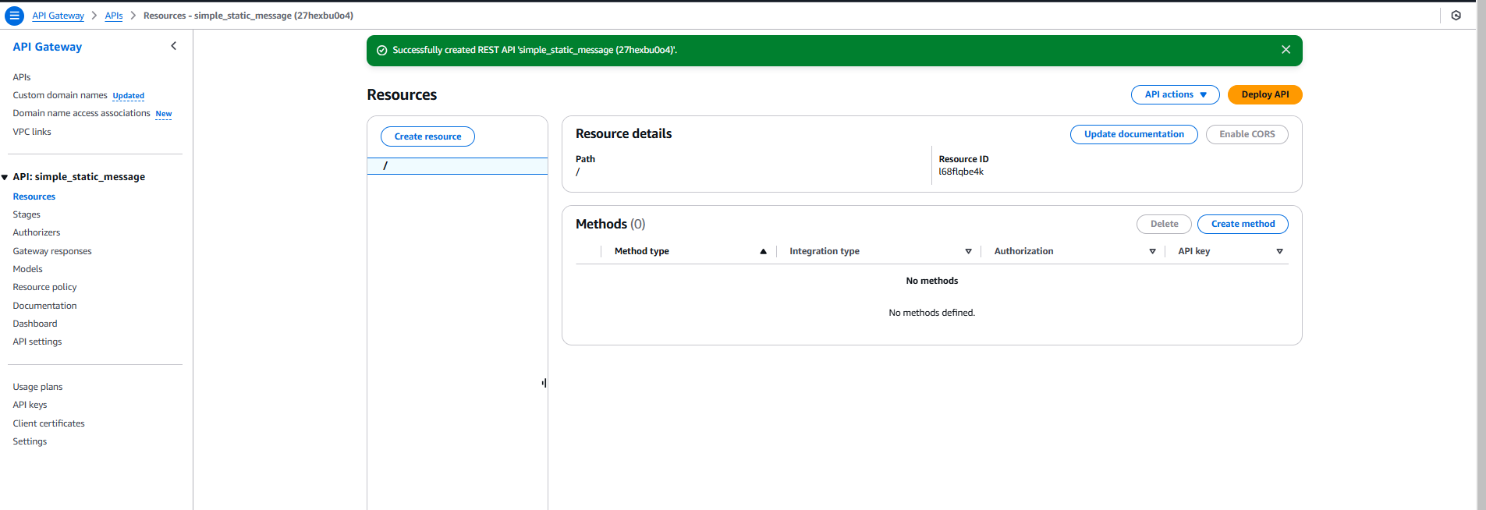
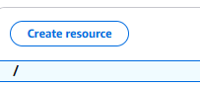
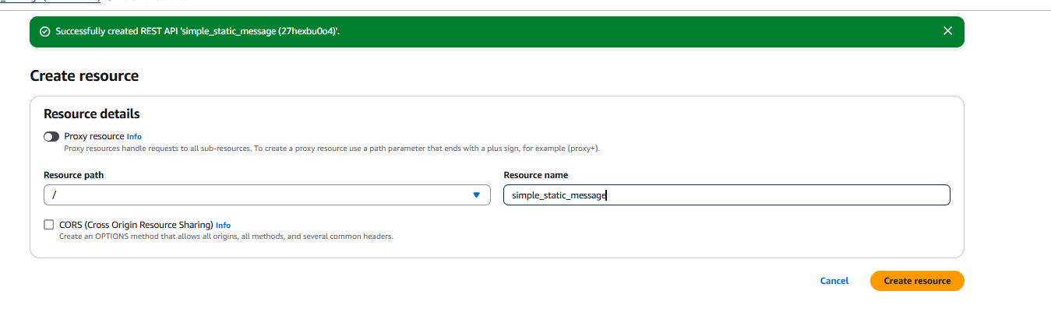
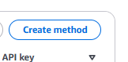
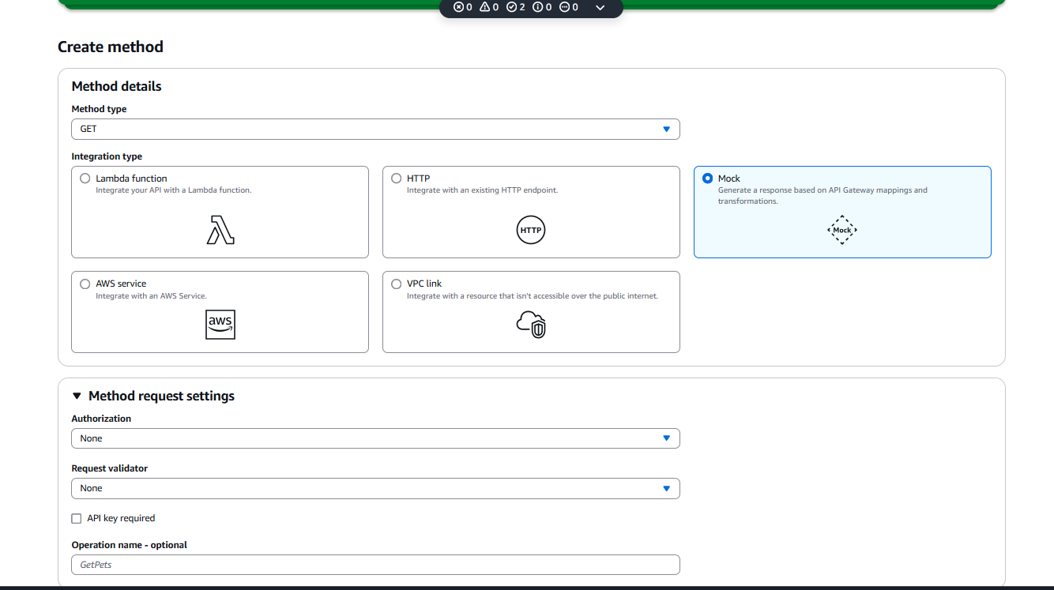
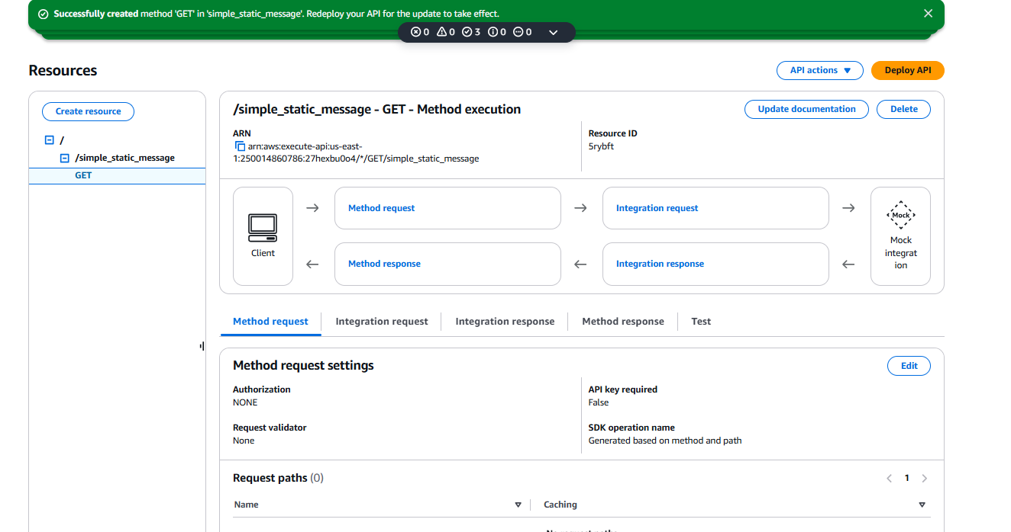
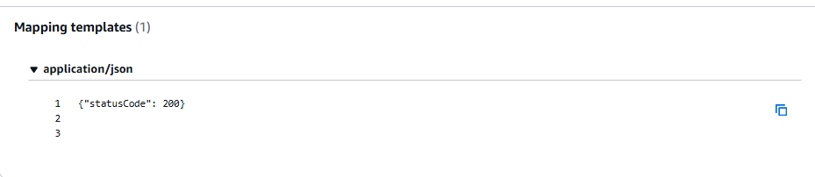
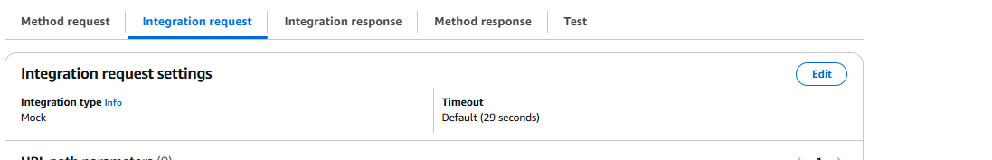
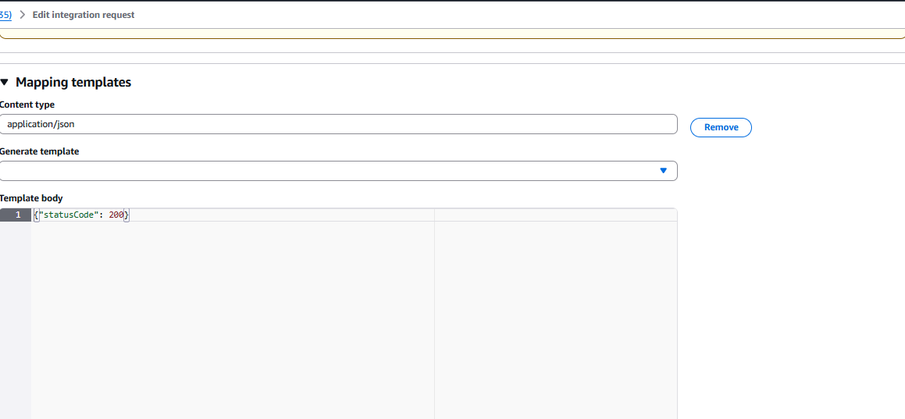
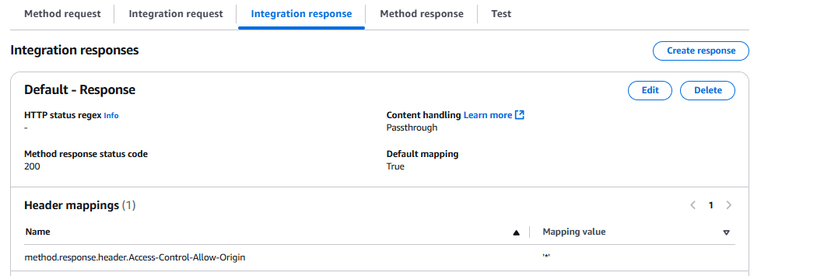
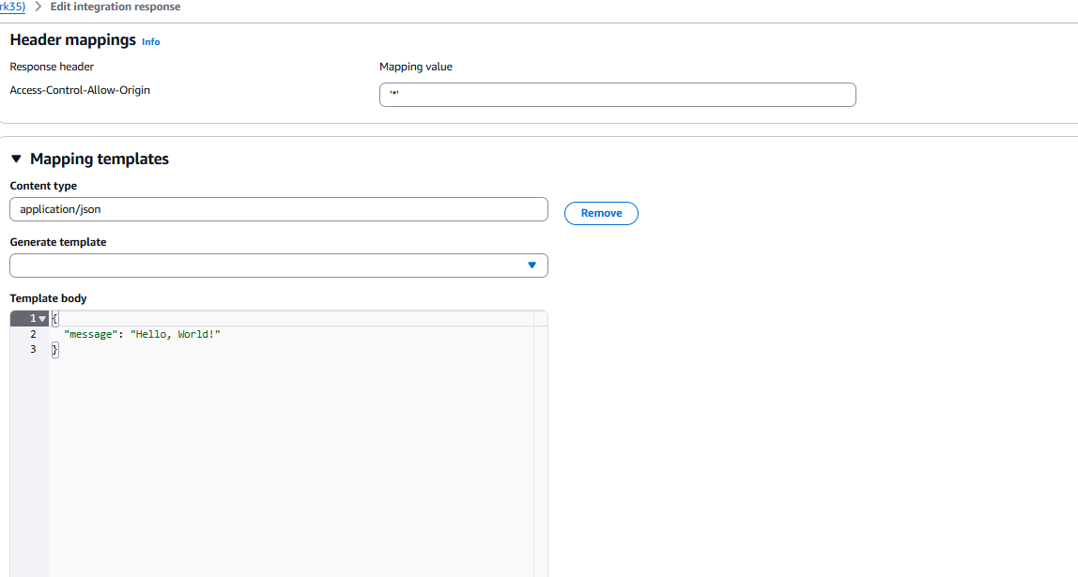
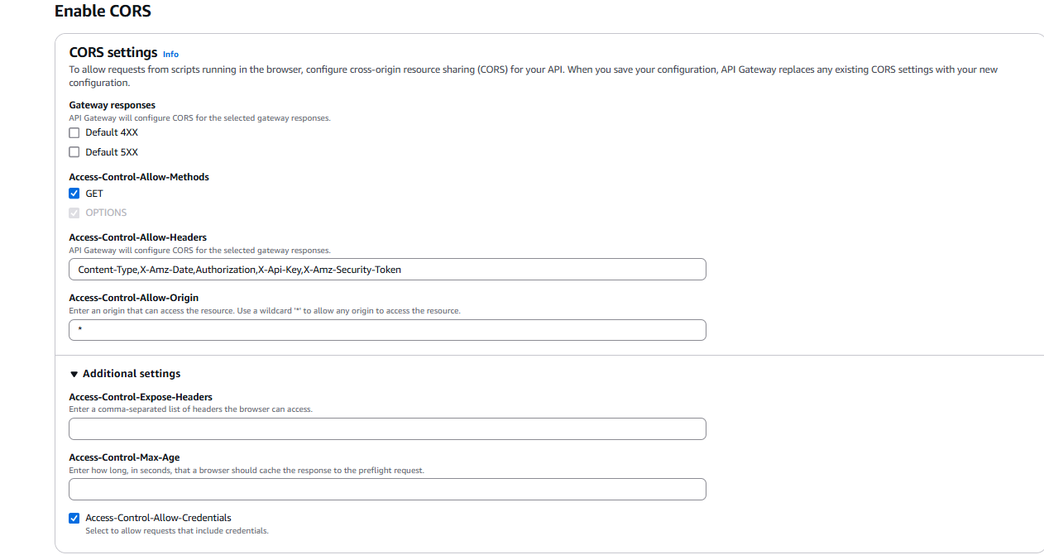
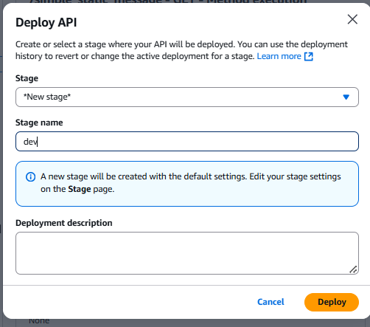
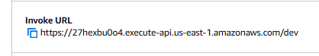
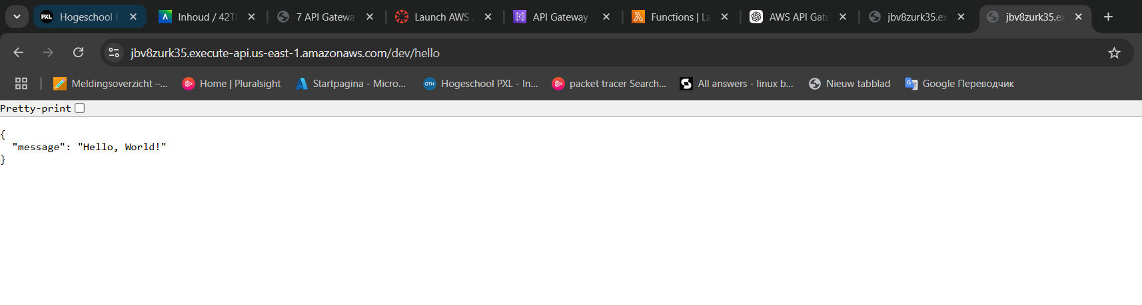
Exercise 2
Create a Lambda function that processes a request and returns a greeting message based on a users input. Create a POST method in API Gateway that triggers a Lambda function.
The lambda function takes in an object with a property name and a value. It returns the message greetings <name>!.
Configure request templates in API Gateway to pass request data to the Lambda function.
Test the API by sending a POST request with a JSON payload { "name": "Alice" } using Postman / Insomnia.
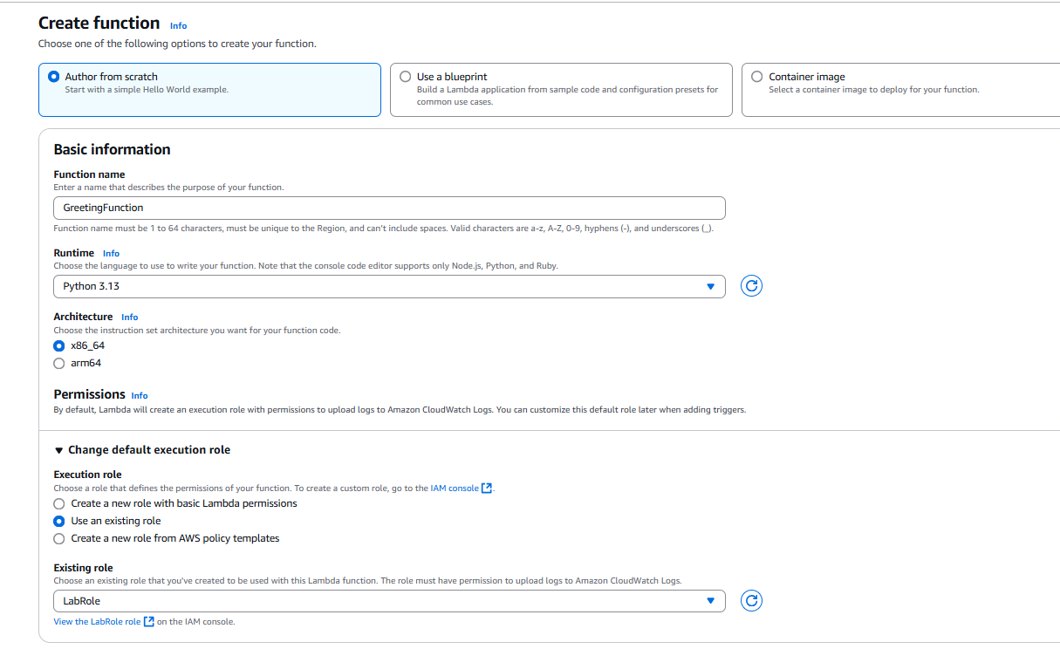
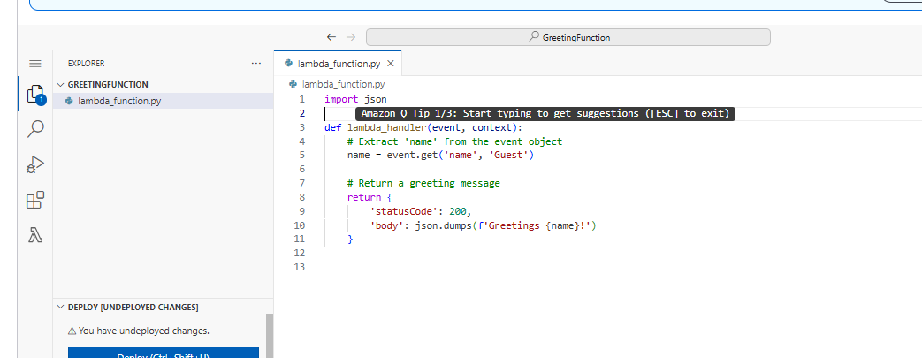
import json

def lambda_handler(event, context):
# Extract 'name' from the event object
name = event.get('name', 'Guest')

# Return a greeting message
return {
'statusCode': 200,
'body': json.dumps(f'Greetings {name}!')
}

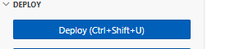
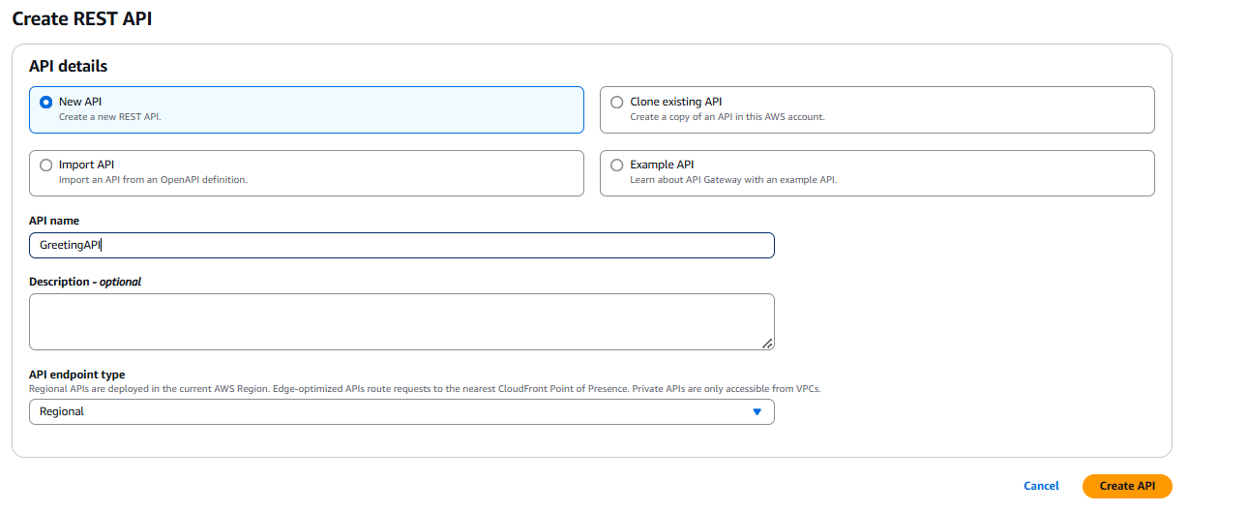
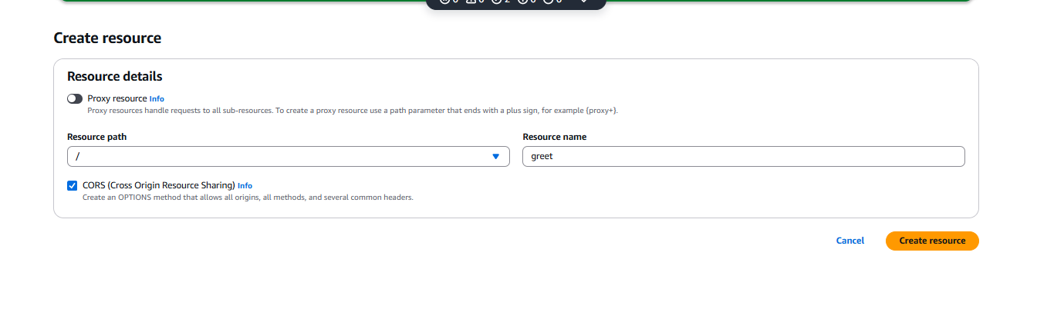
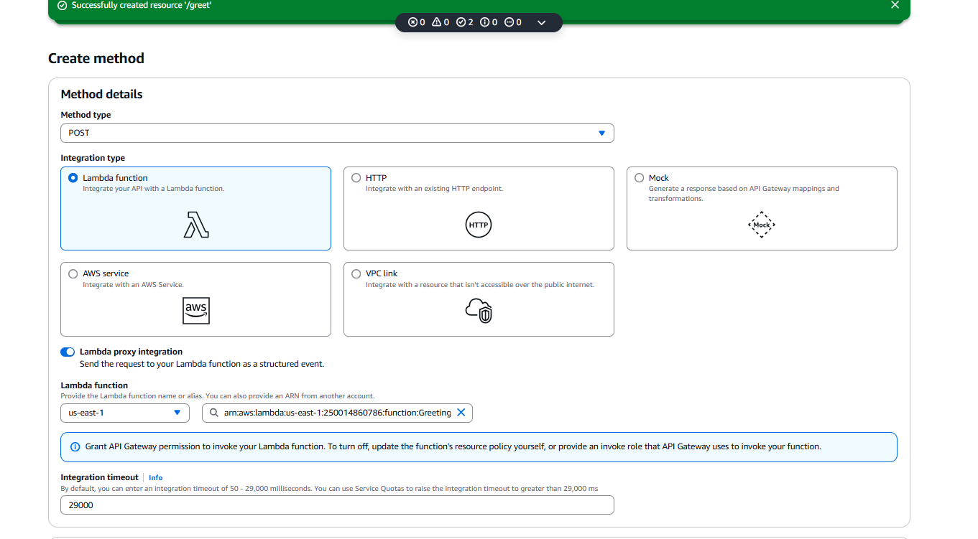

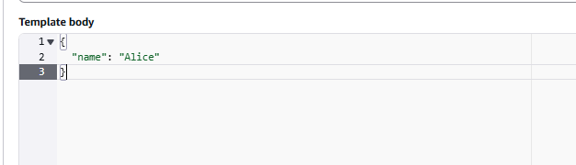
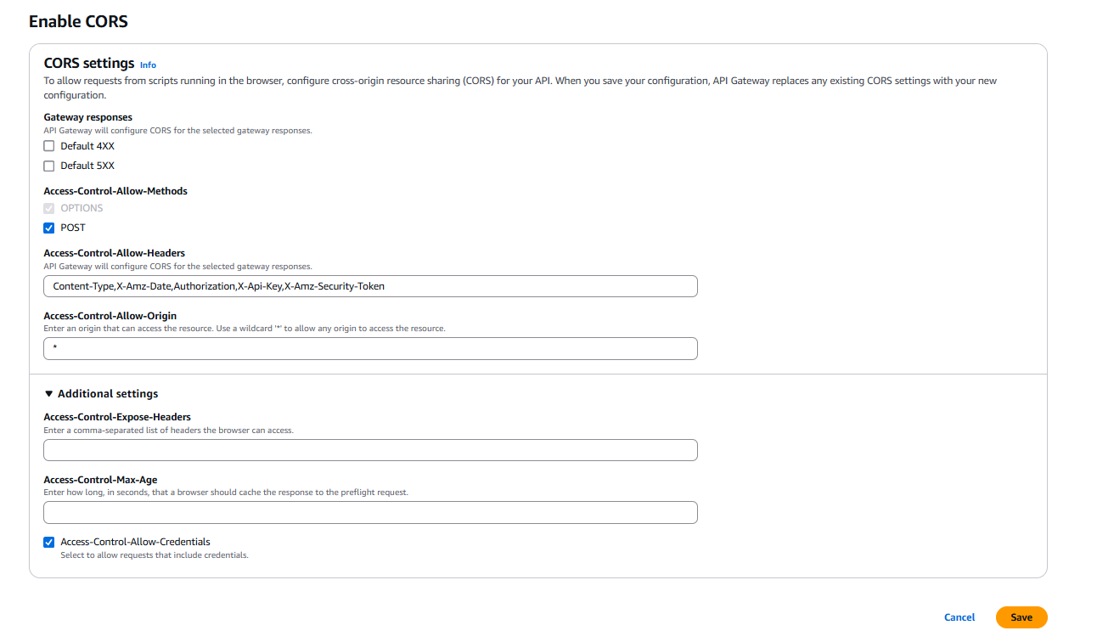
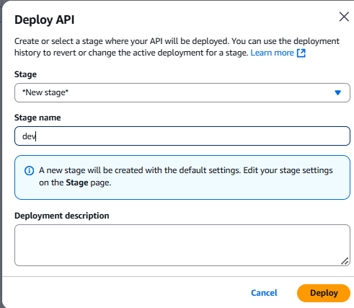
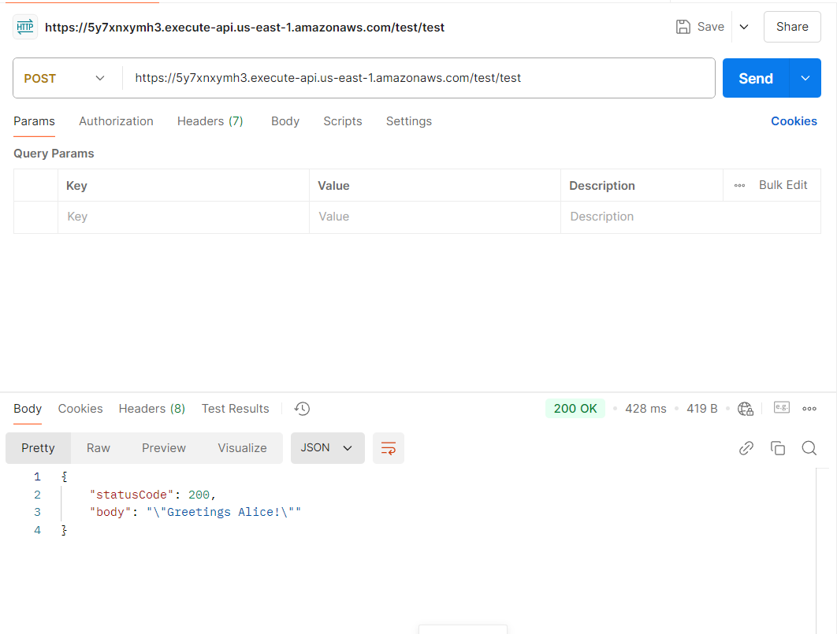

Exercise 3
Follow the tutorial on https://docs.aws.amazon.com/apigateway/latest/developerguide/http-api-dynamo-db.html to create an API gateway that uses lambda functions to interact with a DynamoDB table (steps 1-8).
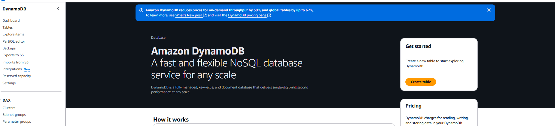
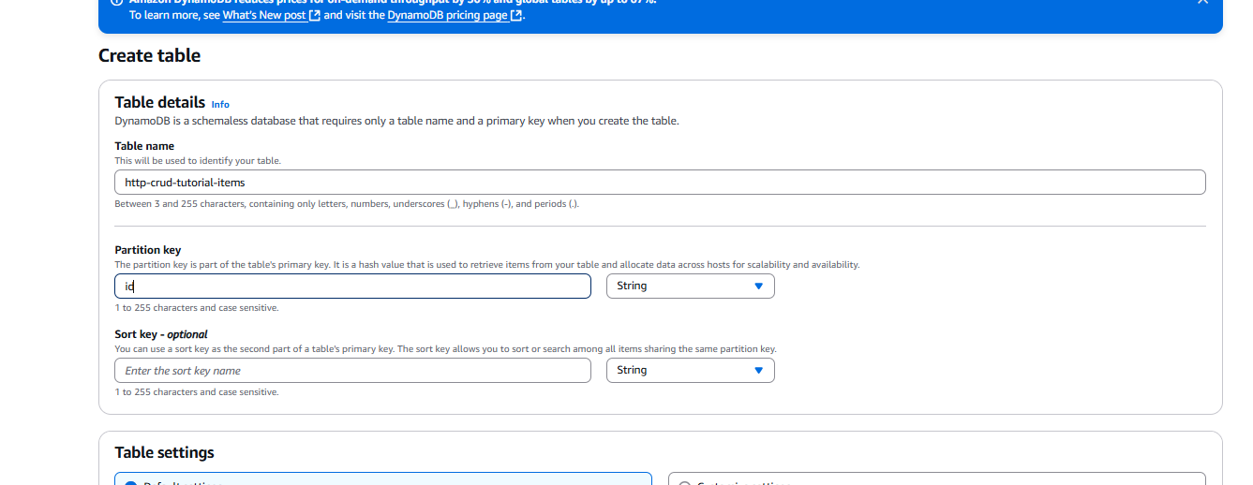
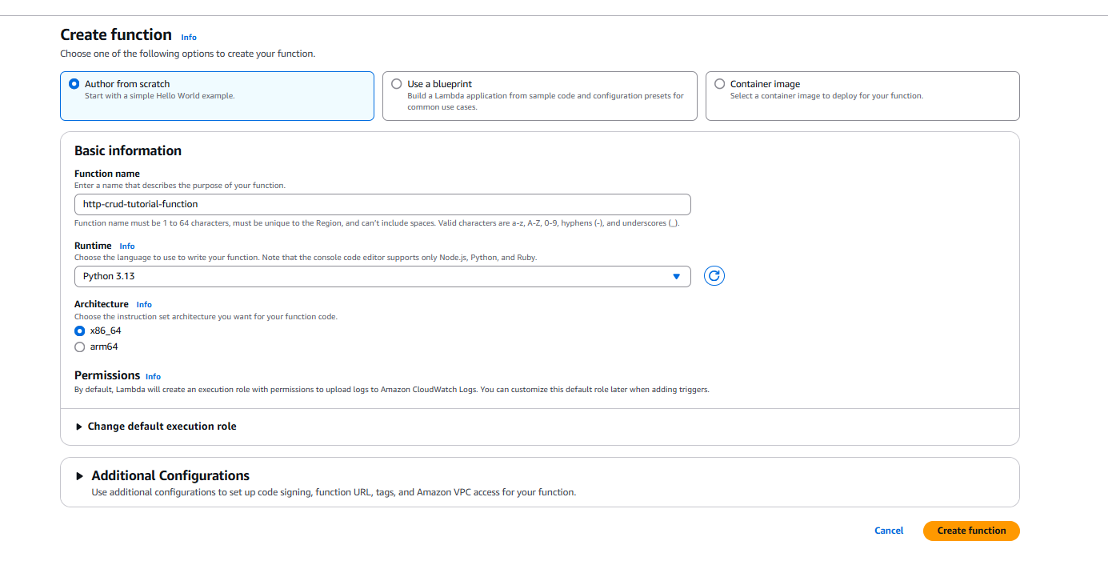
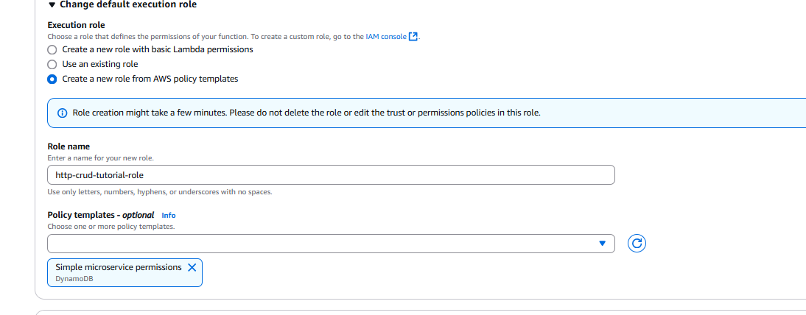
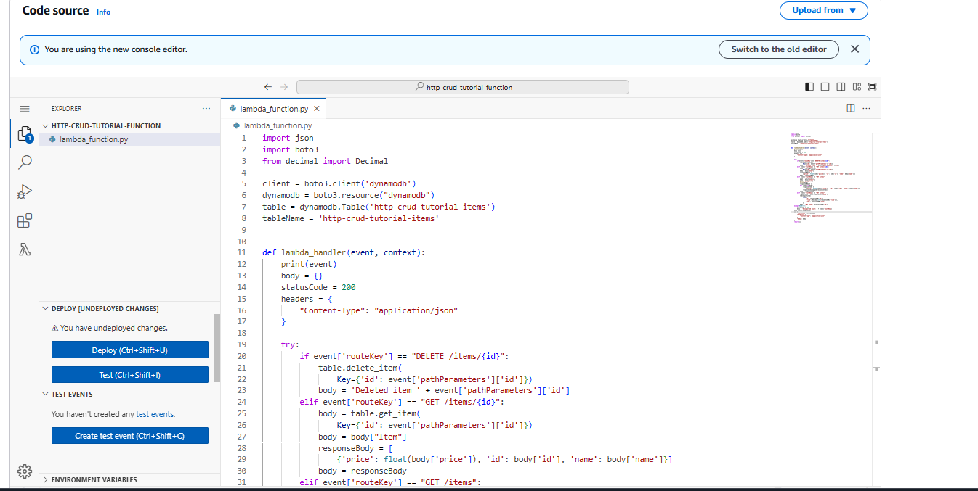
import json
import boto3
from decimal import Decimal

client = boto3.client('dynamodb')
dynamodb = boto3.resource("dynamodb")
table = dynamodb.Table('http-crud-tutorial-items')
tableName = 'http-crud-tutorial-items'

def lambda_handler(event, context):
print(event)
body = {}
statusCode = 200
headers = {
"Content-Type": "application/json"
}

try:
if event['routeKey'] == "DELETE /items/{id}":
table.delete_item(
Key={'id': event['pathParameters']['id']})
body = 'Deleted item ' + event['pathParameters']['id']
elif event['routeKey'] == "GET /items/{id}":
body = table.get_item(
Key={'id': event['pathParameters']['id']})
body = body["Item"]
responseBody = [
{'price': float(body['price']), 'id': body['id'], 'name': body['name']}]
body = responseBody
elif event['routeKey'] == "GET /items":
body = table.scan()
body = body["Items"]
print("ITEMS----")
print(body)
responseBody = []
for items in body:
responseItems = [
{'price': float(items['price']), 'id': items['id'], 'name': items['name']}]
responseBody.append(responseItems)
body = responseBody
elif event['routeKey'] == "PUT /items":
requestJSON = json.loads(event['body'])
table.put_item(
Item={
'id': requestJSON['id'],
'price': Decimal(str(requestJSON['price'])),
'name': requestJSON['name']
})
body = 'Put item ' + requestJSON['id']
except KeyError:
statusCode = 400
body = 'Unsupported route: ' + event['routeKey']
body = json.dumps(body)
res = {
"statusCode": statusCode,
"headers": {
"Content-Type": "application/json"
},
"body": body
}
return res

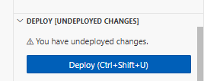
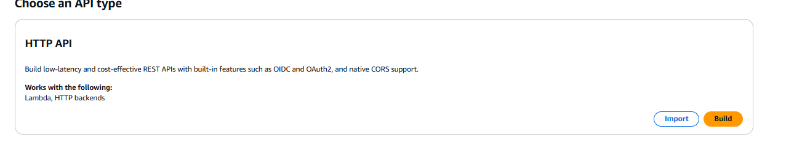
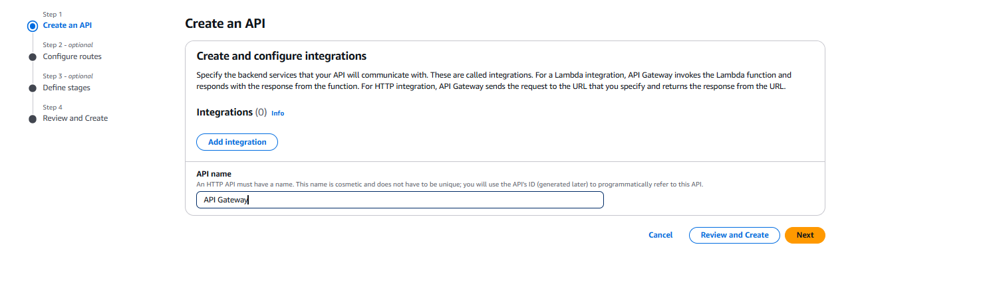
Revieuw and create
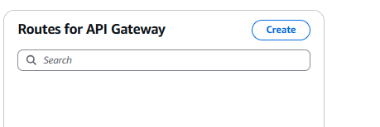
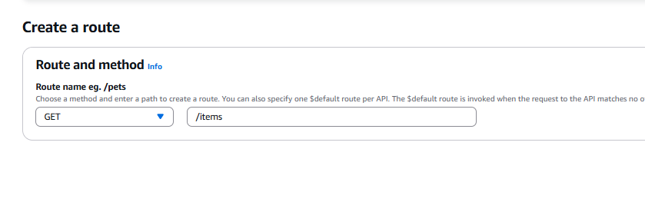
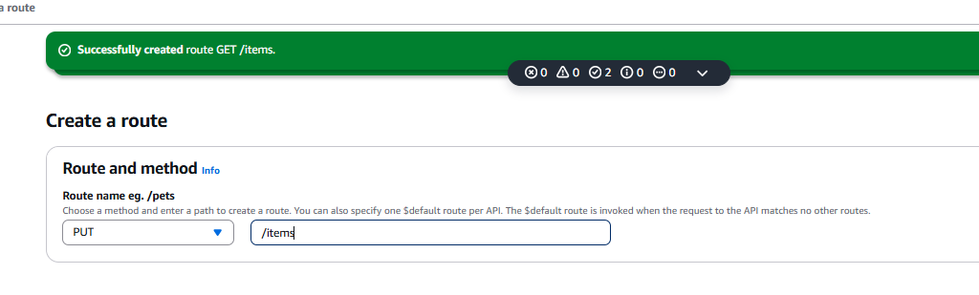
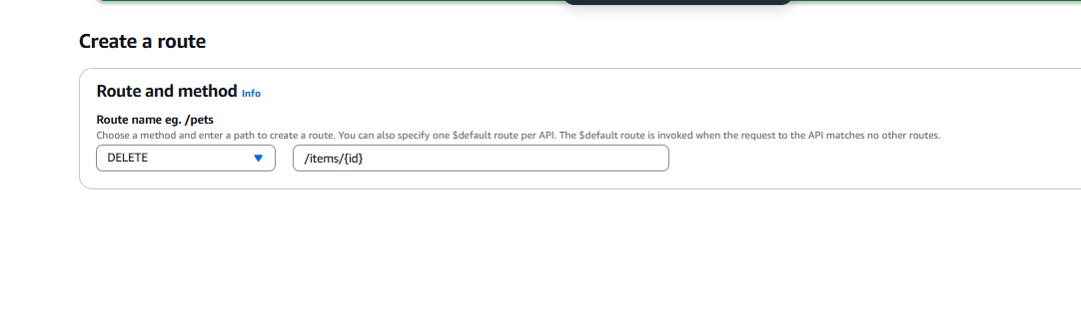
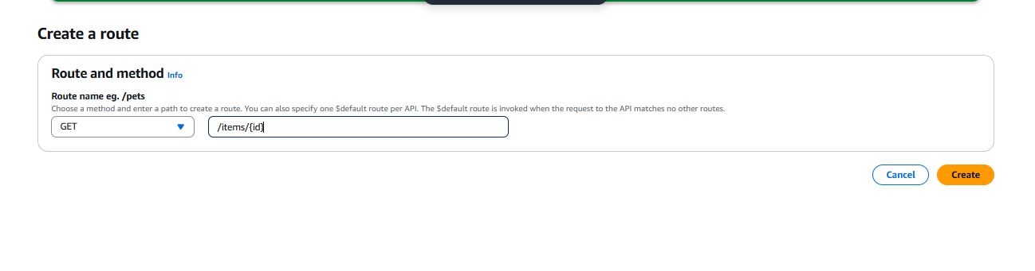
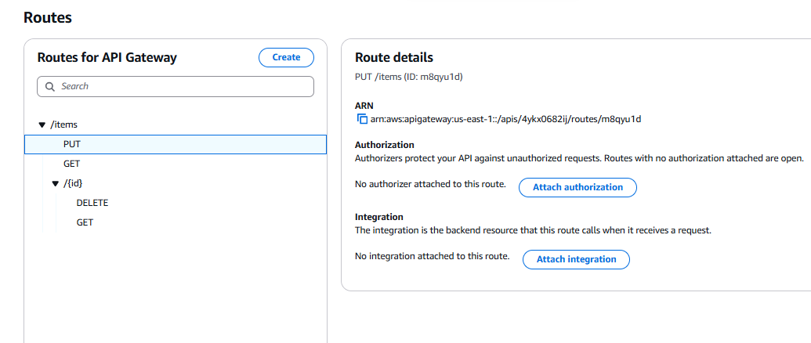
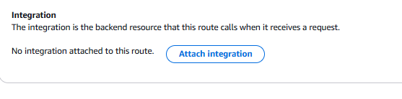
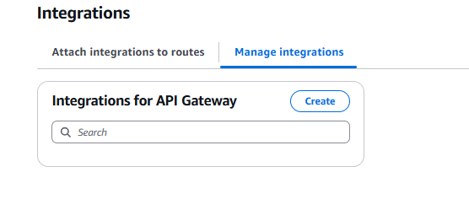
Create
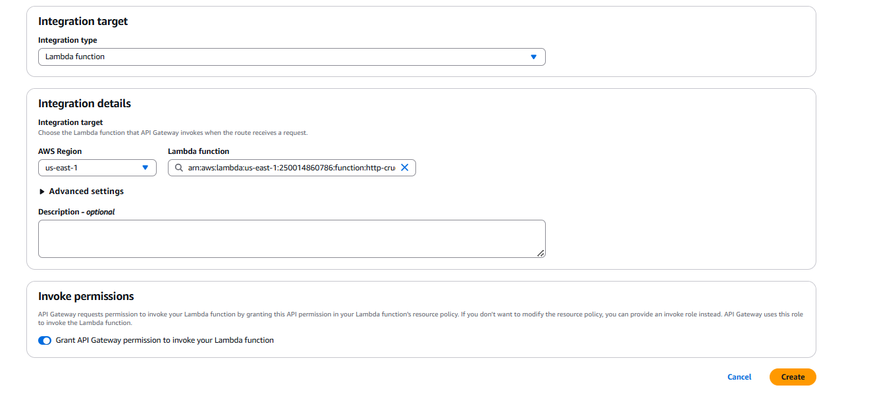
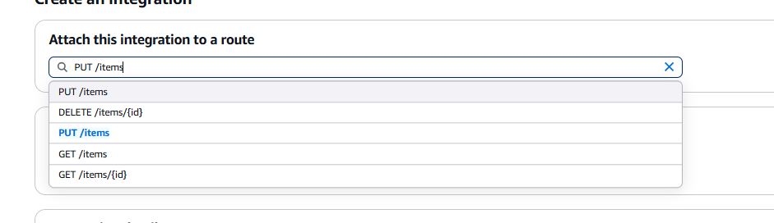
Doe voor elke route
